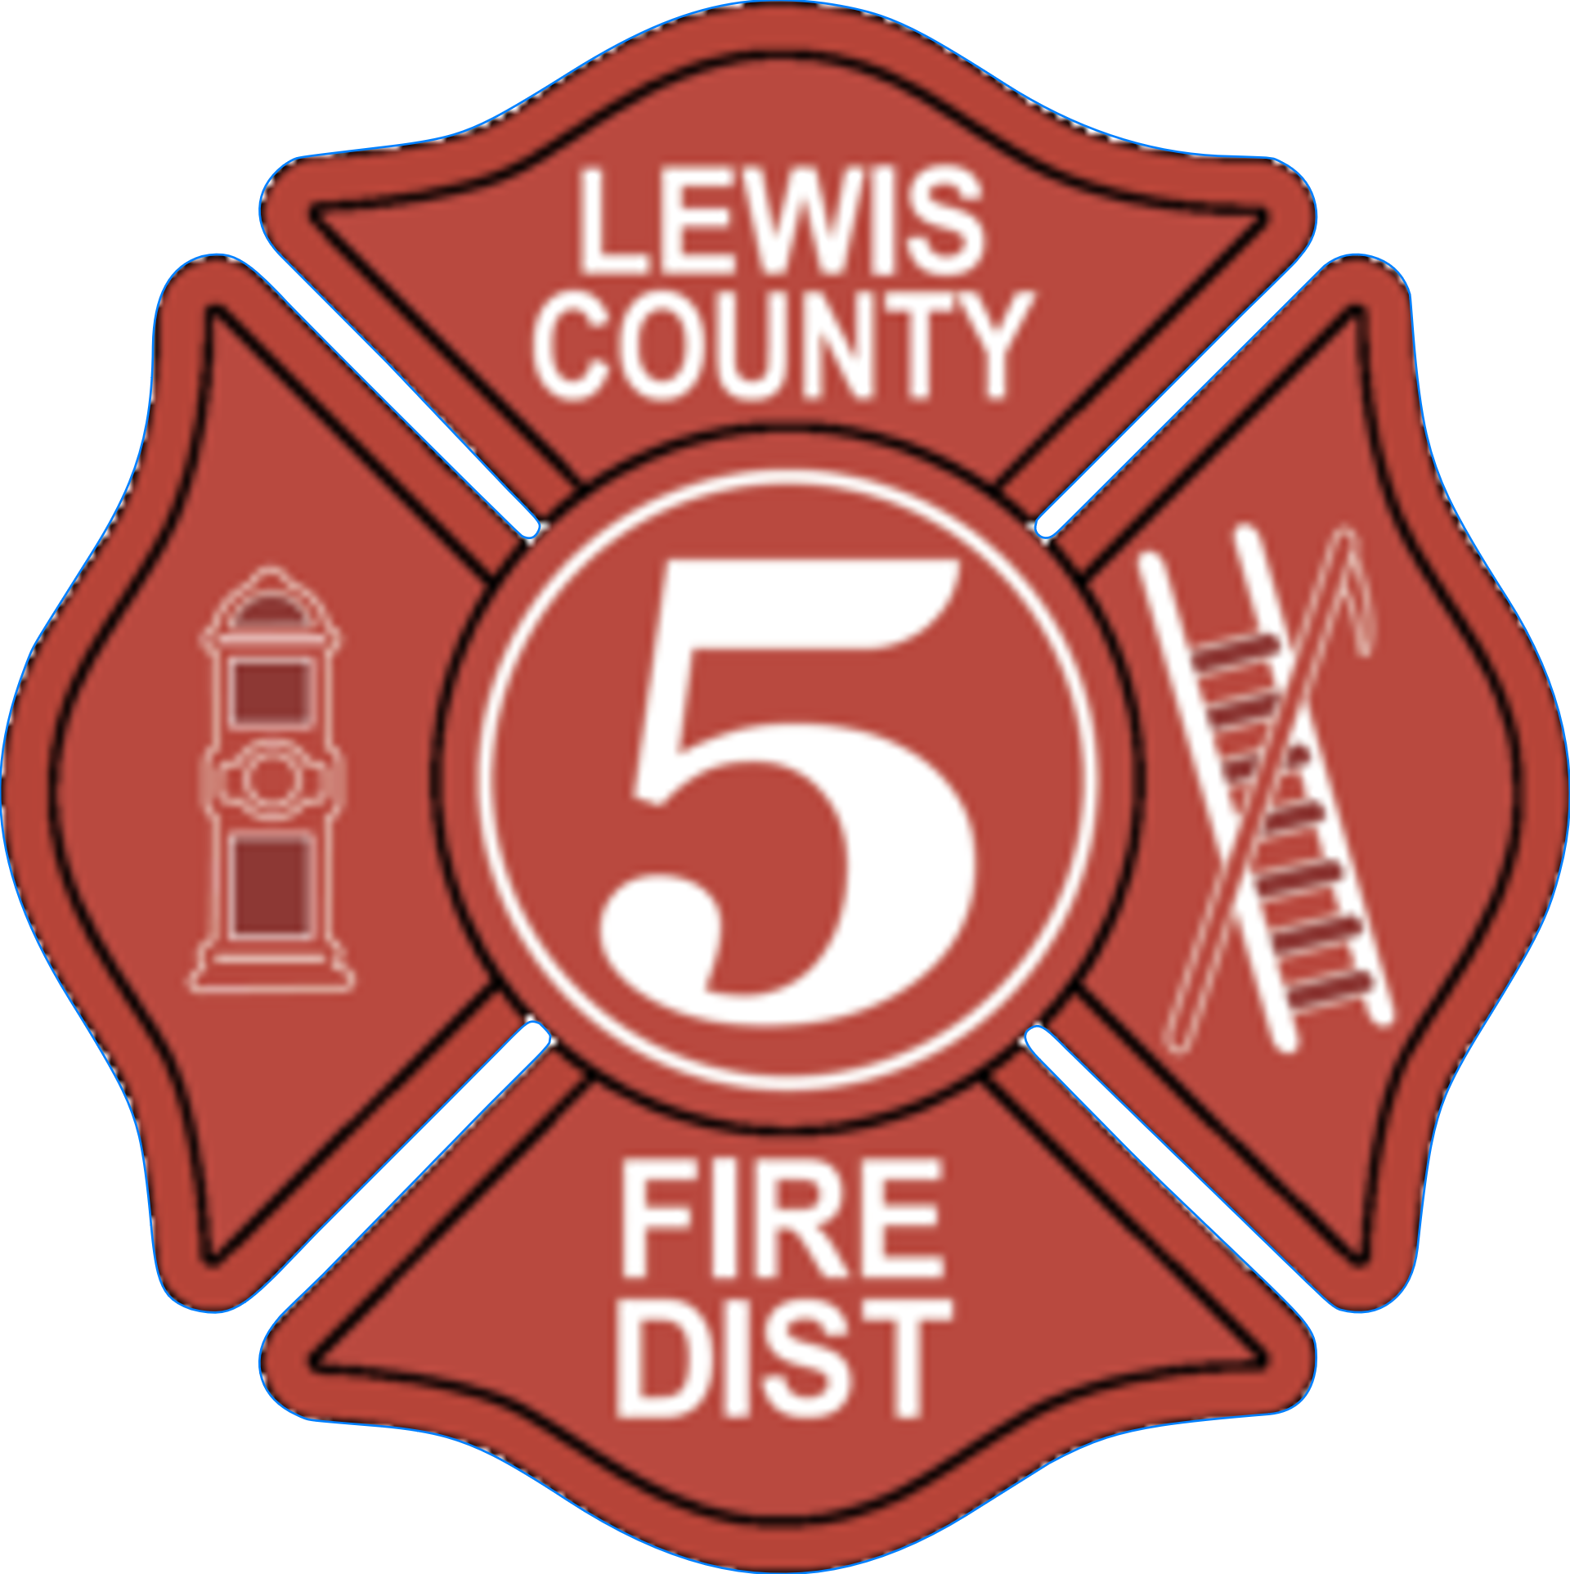

COMMISSIONERS: SAM PATRICK, SANDRA WHITE, & MIKE GOODWILLIE

CHIEF GREGG PETERSON; SECRETARY CARMEN SUNDIN

**BOARD OF COMMISSIONERS**

**SPECIAL MEETING NOTICE**

**PRESENTATION by the LEWIS COUNTY ASSESSOR**

**Wednesday, August 20, 2025**

**at 6:00 p.m.-8:00 p.m.**

**at**

**Lewis County Fire District 6**

**located at 2123 Jackson Hwy, Chehalis, WA**

PURPOSE:

City of Chehalis Annexation of UGA of properties within boundaries of Lewis County Fire District 5 & Lewis County Fire District 6